HOSPITAL MANAGEMENT SYSTEM
TEAM MEMBERS
Mehul Gupta 22515000077
Vidhi Gupta 22515000161
Kanishk Saxena 22515000062
Deepanshu Thakur 22515000042
Chitransh Raj 22515000040
Nikhil Varshney 22515000089
INTRODUCTION
The Hospital Management System is a C-based console application that helps hospitals maintain patient records, doctor information, appointments, billing, and discharge logs. The system replaces manual record-keeping with a faster and more accurate digital process. It allows admins to manage doctors and generate bills, while patients can be registered, assigned doctors, and discharged. The project demonstrates file handling, structures, and menu-driven programming in C.
OBJECTIVES
- To create a simple and efficient hospital record-keeping system.
- To store patient and doctor data using file handling.
- To automate tasks such as billing, doctor assignment, and discharge logs.
- To practice the use of structures, loops, functions, and menus in C.
- To design a program that is user-friendly and easy to operate for hospital staff.
SOFTWARE AND HARDWARE REQUIREMENTS
Programming Language: C
Compiler: GCC (MinGW) / Turbo C (any standard C compiler)
Operating System: Windows / macOS / Linux
Hardware: Basic PC/Laptop with keyboard
FLOWCHART
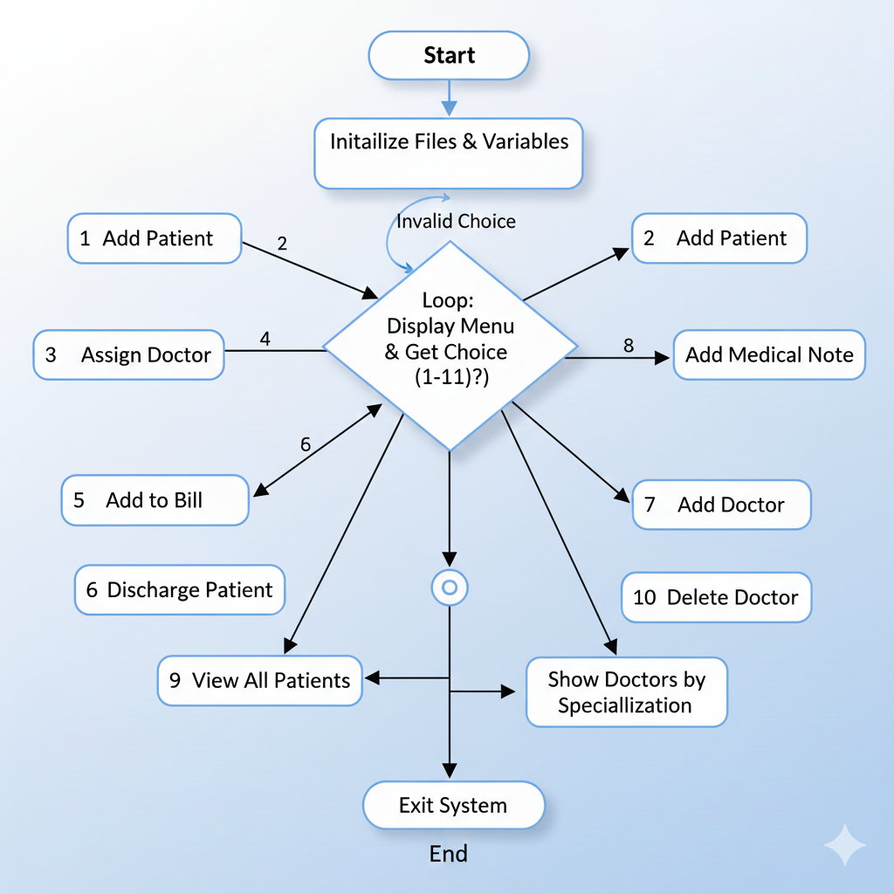

IMPLEMENTATION DETAILS
Major Modules:
1. Add Patient
Stores patient details such as ID, name, disease, assigned doctor, bill, and notes in patients.dat.
2. Assign Doctor
Matches patient’s required specialization with available doctors and updates doctor ID.
3. Add Medical Note
Adds diagnosis or treatment notes to a patient’s record.
4. Automatic Billing System (Admin)
Admin selects services used by patient (X-ray, MRI, CT scan, surgery, medicine, room stay), and the system calculates total bill automatically.
5. Add / Modify / Delete Doctor
Admin can manage doctor records using doctors.dat.
6. Appointment Booking
Links patient and doctor with a date record in appointments.dat.
7. Discharge Logging
Writes discharge summary (name, bill, doctor ID) into hospital_log.txt.
RESULTS
1 → Add Patient
Enter ID: 101
Enter Name: Riya
Enter Disease: Fever
Patient Added Successfully!
6 → Add Doctor
Enter ID: 11
Enter Name: Sharma
Enter Specialization: Physician
Doctor Added Successfully!
2 → Assign Doctor
Patient ID: 101
Specialization: Physician
Doctor Assigned Successfully!
CONCLUSION
This project helped us understand how real hospital systems store and manage data. We learned important concepts such as structures, file handling, functions, and menu-driven programming in C. The system simplifies record-keeping and reduces human error. In the future, the project can be improved by adding password protection for patients, graphical UI, sorting/filtering of data, and database connectivity for large-scale hospitals.
SOURCE CODE FILE:
OUTPUT EVIDENCE DRIVE LINK:

